|  |  |
| --- | --- |
|  | **Roslyn Cemetery**  **Lesson Five – Grade Four**  **Roslyn’s Labor Movements**  A person in a tunnel with a flashlight  Description automatically generated with medium confidenceRoslyn’s history is deeply intertwined with the labor movement history of the United States. National unions such as the Knights of Labor were present in Roslyn’s early days as a coal mining town. In the late 1800s and into the 1900s, the Northern Pacific Coal Company and its parent company, the Northern Pacific Railway, employed miners to extract the coal that would fuel trains, homes, and businesses. Coal miners endured dangerous working conditions, long hours, low wages, and the ever-present threat that the company would decide to temporarily close mining operations as a tactic to ignore union demands and force workers back into the mines.  In this lesson, students will learn the meaning of terms such as workers’ rights and labor unions, and consider how strikes impact workers, their families, and corporations. Students will also learn about the labor movement in Washington State by viewing a photo showing miners protesting for safer working conditions at the state capitol in 1933 and discussing worker rights. |

Additionally, students will create their own union in small groups, imagining themselves as “workers” in a drive-in who are fighting for change from their “employers” (i.e., drive-in owners). The lesson culminates in the creation of a poster or brochure to advertise their union, its demands, and their strategies to fight for additional **worker rights**.

State Standards:  
SSS3.4.1 Draw on disciplinary concepts to explain the challenges people have faced and  
opportunities they have created in addressing local, regional, and global problems at various  
times and places.  
SSS4.4.1 Draw clear, well-reasoned conclusions with explanations that are supported by print  
and non-print texts in a paper or presentation.  
E4.4.2 Explain the economic issues that different communities within the Pacific Northwest  
faced.  
H2.4.1 Analyze and explain how individuals have caused change in Washington state history.

Essential Questions  
● What is the labor movement and what are unions?  
● Why do workers participate in unions and what are the benefits of being in a union?  
● What rights do workers have today that were a result of the labor movement?

Essential Understandings  
● Unions enable collective bargaining by workers to fight for specific demands to improve  
working conditions  
● Roslyn union members faced pushback from the coal companies as they fought for  
specific demands to improve conditions in the mines

Primary Sources

* Britannica Kids – Labor Union  
  <https://kids.britannica.com/students/article/labor-union/631741>
* Youtube -- A Brief History of Labor Unions

<https://www.youtube.com/watch?v=ubIWyT7nGdU>

* Roslyn Miners at Olympia -- photo
* United Miner’s Flag

Teacher Prep  
Preview and print all materials needed for this lesson.  
Read: <https://wsupress.wsu.edu/2014/09/23/examining-roslyns-dramatic-labor-history/>  
Review: <https://usafacts.org/articles/labor-union-membership/>

**Additional Teaching Resources:**Zinn Education Project: <https://www.zinnedproject.org/>  
Seattle Civil Rights and Labor History Project: <http://depts.washington.edu/civilr/index.htm>  
Why Teach Labor History? <https://www.aft.org/sites/default/files/periodicals/green.pdf>

**Introduction Activity**

Preview the vocabulary students will need to know for this unit.

|  |  |  |
| --- | --- | --- |
| **Vocabulary Word** | **What I think it is** | **What I have learned** |
| Boss |  |  |
| Owner |  |  |
| Manager |  |  |
| Labor |  |  |
| Labor Union |  |  |
| Fair Wages |  |  |
| Worker Rights |  |  |
| Fair Hours |  |  |
| Safety |  |  |
| Strike |  |  |
| Collective Bargaining |  |  |

Watch this video about **Labor Unions**. Fill out this chart before you watch, as you watch, and after you watch the video. Video [here](https://www.youtube.com/watch?v=ubIWyT7nGdU). (<https://www.youtube.com/watch?v=ubIWyT7nGdU>)

|  |  |  |
| --- | --- | --- |
| What you already know about Labor Unions (this can also be an educated guess) | What you learn during the video | What questions you still have or want to know more about |
|  |  |  |

**Activity #1: Labor Union Simulation**

|  |  |
| --- | --- |
| **The Story** | **Question and Notes** |
| You walk through the door of the fast-food restaurant. It's your first day at work. As you walk behind the counter you notice all the employees hard at work. You see some flipping burgers. You can hear the burgers sizzle and pop. You can smell the hot oil and the french fries cooking. You hear your **boss** calling out to the employees, telling them to work faster. You can feel the tension rise and the employees try to work harder, faster.  Suddenly, another employee hands you a wet rag and tells you to start wiping down trays. So you start wiping down trays. You feel like you have finally caught up. You sit back, look up and see another huge stack of dirty trays sitting in front of you. With a big sigh you get back to wiping trays.  You wipe tray after tray--for six hours, eight hours, ten hours. Your arms are tired and aching. Your hands are wrinkled from the soapy water. You want to do something else, but when you ask the boss if you can leave or do another job, she says to keep wiping trays. Day after day, all you do is wipe trays.  One day, another worker tells you that some of the workers are meeting later to talk about how hard the work is--and how mean the boss is. So you go and hear people talking about how unfair things are. They talk about how the boss won’t listen to them—the only way they will make the boss listen to their requests is if they all agree to ask for the same thing at the same time—as a group. This is **collective bargaining**—offering as a group to only work if the group gets paid more or has better working conditions. Maybe if the boss sees that all her workers are frustrated, she’ll listen to their problems. | *Imagine you are in this scene - what are you thinking? What are you feeling?*  *Have you ever had an experience like this before? What were you thinking? Feeling?*  *Do you think this is fair? Why or why not?*  *Is it ok to be asked to do something that is unpleasant?*  *Is it ok to be asked to do something that is unsafe or unhealthy?*  *Do you think going to the boss as a group might work? Why or why not?* |

This is the start of a union. What is a **union**?   
  
It’s a group of workers who do the same kind of job and who meet together to discuss concerns about their jobs. When they meet together and agree to act as one group and choose leaders to speak to the boss for them, then they are becoming part of a **labor** (work, jobs) **union** (group, organization).

**Discuss and take notes: What unions can you think of that exist today? Why would people want to be part of a union?**

|  |
| --- |
|  |

**What do you think the workers could do if they take their problems and concerns to the boss, and the boss refuses to help or change anything? Discuss and write down ideas.**

|  |
| --- |
|  |

Sometimes workers who belong to a union may decide not to work at their jobs until the bosses give them what they want. That’s called a “**strike**.” If grocery clerks go on strike, they don’t go to work until they can reach an agreement with the grocery store **owners**. The clerks, instead of working, may march outside of the store carrying signs that say the store is unfair to them. When they refuse to work and go on strike, that puts pressure on the store owners, because the owners need workers for the store to keep making money. The owners also need customers to shop at the store, and customers may stay away from a store to show that they support the workers who are on strike. Workers who are on “strike” don’t do any work until the owner agrees to give them what they want, or part of what they want, or until they need money badly enough—and they agree to start working again.

**When workers go on strike, they don’t get paid. How would it affect your family if your parents were on strike and didn’t get paid for several months? How long could you get by without having money? For food? For toys?**

|  |
| --- |
|  |

**Connection to Roslyn**

The families who lived in Roslyn relied on working in coal mines to have money to live on. Almost all the men worked in the coal mines. They would ride on narrow train tracks and go deep underground in narrow tunnels. When they got to the end of the tracks, they would begin shoveling the black rocks of coal into the coal cars, the carts that took coal from down in the ground out to the surface. They would shovel the heavy coal almost all day. It was hard work. The air was always dusty and smelly. Sometimes dangerous pockets of gas would form and could explode if there was a spark of fire.

The coal miners were expected to work long days, and the work was very tiring and dangerous. At the end of the day, most of the miners left the mine while some stayed behind and put dynamite in the rocks. Then they would explode the rocks. The dust settled overnight, and the next day the miners would start again shoveling the broken coal into the carts.

The coal mines were owned and managed by a railroad company, the Northern Pacific Railway. So, the railroad owners decided who could work in the mines, how long they would work, how much they would be paid, and what kinds of equipment were needed to keep the mine safe.

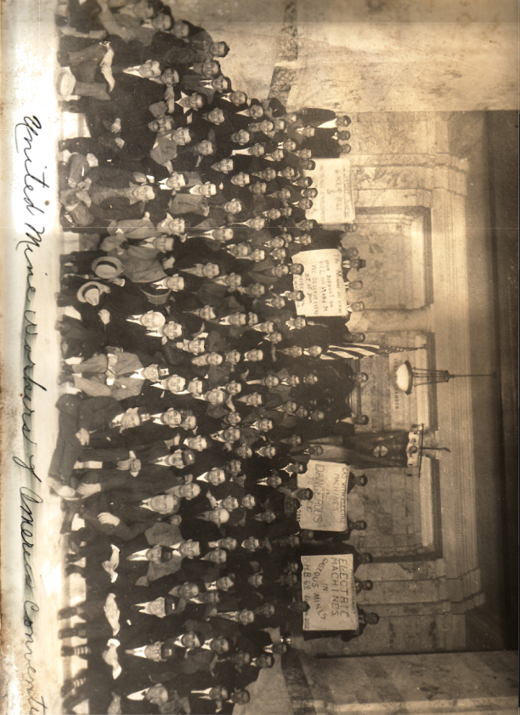

Look carefully at this photo:

You see a lot of men sitting on the steps of the state capital in Olympia in 1933. You see that they are holding up four signs. If you look closely, you can see that the signs read:

**“Support Miners Six-hour Bill”**

**“The Miners are asking Your Support on Bill 69 and 70.   
--We deserve every bit of your support.”**

**“Gas with electric machines is dangerous to see.”**

**“Protest against electric machines in gaseous mines.”**

All these men traveled from Roslyn to the Washington State Capitol in Olympia, 120 miles away, to protest their **unsafe working conditions**. The men wanted to be able to work shorter hours each day to avoid making mistakes and causing accidents. They wanted to work for six hours inside the mine each day instead of eight hours. And they wanted not to use electric machines in the mines because the sparks from the electric machines could cause fires that would burn them.

So, the men traveled to Olympia as a group to show that they all thought their work place was not safe, and they needed the rules to change so they could be safer.

These miners, working together as a union, eventually got some of the changes they were seeking. Their workday was reduced from eight hours to seven. They received raises in pay that helped their families have better lives. And their bosses, the railroad **managers**, tried to make sure that the machines the miners used were made safer.

Roslyn miners joined a union soon after the mines opened in 1888. The first union they joined was the Knights of Labor, which later became the United Mine Workers of America.

**Discussion Questions:**

1. **What did the railroad want?** –*coal to fuel trains, to bring products from the east like food and furniture, and to bring products from the northwest like wood and wheat.*
2. **What would happen if the railroad paid the miners less money?** –*men would seek other jobs that paid better, would move away and then railroads couldn’t get any coal.*
3. **What would happen if the railroad paid the miners lots of money?** –*they would have to raise prices for the goods that they shipped on the railroad, so everything would cost more and people couldn’t afford it.*

**Labor Movement**

**What We Do & Don’t Know**

*(adapted from “What Rights Do We Have?” from the Zinn Education Project)*

1. How long have there been unions or similar forms of worker organization?

(a) Since the different craftspeople built Noah’s ark

(b) Since the time of the great Egyptian pyramids

(c) Since the brewers and weavers in the Middle Ages

(d) Since railroads were built in the nineteenth century

(e) Since the sit-down strikes of the 1930s

2. What do unions do? List all the important things you can think of.

3. Most public-school teachers in the United States are represented by a union: true or false?

4. Which of the following were created because of workers’ struggles or organizing?

(a) Social Security

(b) Workers’ compensation (for people injured on the job)

(c) Unemployment benefits

(d) Minimum wage

(e) Cure for the common cold

(f) Child labor laws (protecting children from heavy work and long hours)

(g) Public education

**Answer key:**

Q1. Workers have organized to protect themselves against worsening conditions ever since some people have labored for others. There are records of worker organization in the building of the pyramids. 1 (b), (c), (d), and (e) all included unions, worker associations, or medieval guilds.

Q2. A complete list would be quite long. The aim of this question is to get beyond “strike” and “negotiates wages, benefits, and working conditions” as the common answers. Some additional answers would include:

* set up committees to strive for worker safety and health
* promote laws favorable to workers
* represent and defend workers in disciplinary proceedings within workplaces
* provide a social gathering place for members or be a training ground in public speaking and running meetings and in grassroots democracy

Q3. True. There are two major teacher unions in the United States, the National Education Association and the American Federation of Teachers. Most teachers belong to one or the other.

Q4. All except (e).

**Reflect and Connect**

Think back over all the lessons we have done so far. What connections can you make between the unions in this lesson and what you learned in the previous lessons?

To help you get going, think about the following:

-Who were the workers?

-Where did they come from?

-What were some problems they faced?

-What jobs / industry did they work in?

**Design a Union**

For this project, you will be putting students into groups of 4 - 5. Give each group a different hypothetical job. This can be jobs from around town, (fast food workers, construction workers) or you can be more creative (candy makers, ice cream testers). Each group will go through the process of making their own union.

**Create Your Own Union**

Names of your group members:

|  |
| --- |
|  |

Your job:

|  |
| --- |
|  |

Name of your union (make sure it is something that other people will respect)

|  |
| --- |
|  |

Why did your group choose this name? What significance does it have?

|  |
| --- |
|  |

What will your list of demands be? Make sure these are specific, but achievable

|  |
| --- |
|  |

How will you negotiate to get your demands met? What will you do if those are not met?

|  |
| --- |
|  |

**Poster Project**

Use the above information to create a poster for your union and their demands. Make it persuasive and easy to understand. You want someone to be able to look at it, understand what you are asking for, and want to support you.

Your poster should include:

* Your union name
* Your union demands (creative and specific, but achievable)
* Why these demands should be supported
* What will happen if they are not met
* Pictures/images of your job

**Wrap Up and Self Assessment**

What percent of American workers do you think are in a union today? Write down your guess

|  |
| --- |
|  |

*The actual number is about 10%.*

Do you think unions are important to jobs today? Why or why not?

|  |
| --- |
|  |

What are the positives and negatives of being part of a union?

|  |  |
| --- | --- |
|  |  |

Write down 3 key facts that you learned from this unit and 2 questions you still have

|  |  |
| --- | --- |
| 3 facts | 2 questions |

Extension activity:

Interview someone you know who is, or who has been part of a union for their job. Write here some questions you would ask them.