|  |  |
| --- | --- |
|  | **Roslyn Cemetery**  **Lesson Two – Grade Four**  **Immigration and Western Expansion,**  **Fraternal Organizations and Lodges**  Roslyn, Washington has a rich and wonderful history. That history can be seen in its buildings and in the cemetery. To help maintain and preserve this history, Rolsyn was added to the **National Register of Historic Places** in 1978. The National Register of Historic Places acknowledges places that are important to our history and helps to protect them.  In the late 1800s and early 1900s people from many different cultures moved into the Western United States, like Washington, Oregon, and California. As a mining town, Roslyn attracted workers from all over Europe and other parts of the United States. This diverse and **multicultural** population can be seen in the cemetery.  Some of the immigrants were looking to leave their home countries because they weren’t sure they could make a good living in their home country. Some of the immigrants traveled straight to Roslyn; others tried to live somewhere else in the United States first and then moved to Roslyn. Some of the people had already worked in mines in England, Wales, and Illinois and came as skilled workers. Others came as unskilled workers, who did not have experience working in mines. |

In 1900 there was a **census** taken. A census counts every person in the United States. It also asks for information like the person’s age and race. The 1900 census found that 40% of Roslyn’s population was born in another country, or foreign born. Many of those foreign born were Italian or Slavic. The census also found that 22% of Roslyn’s population was black.

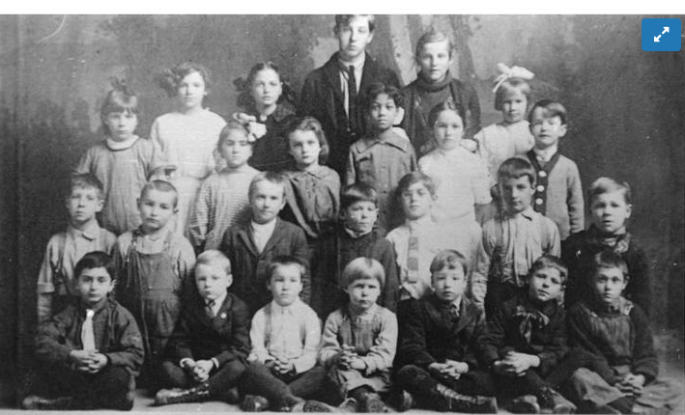

Roslyn, Washington students representing 24 nationalities, 1913

People of various cultures and **heritages** lived and worked together in Roslyn. They were also buried near each other in the Roslyn cemetery. If you walk through the cemetery you will see slavic languages on tombstones, and **Eastern Orthodox** crosses on Serbian graves. While this is specifically Roslyn’s history and story, it reflects the story that happened throughout America.

# **Vocabulary**

|  |  |  |
| --- | --- | --- |
| **Word** | **Dictionary Definition** | **My Definition** |
| **National Register of Historic Places** |  |  |
| **multicultural** |  |  |
| **census** |  |  |
| **heritages** |  |  |
| **Eastern Orthodox** |  |  |

# **Activity #1: Immigration:** Answer the questions and then create a key for the map.

|  |  |
| --- | --- |
| **Question** | **Answer** |
| What types of transportation were available in the late 1800s and the early 1900s? |  |
| When emigrating from their home country to America, what items do you think people brought with them? |  |
| How long would it take to get from Italy to America using the transportation back then? |  |
|  |  |
|  |  |

Create a key that connects the culture and countries represented on the map of the Roslyn Cemetery with the countries on the world map. Choose a symbol (#, *, +). Use the same symbol to show what country groups of people came from and where they are buried at the Roslyn cemetery.

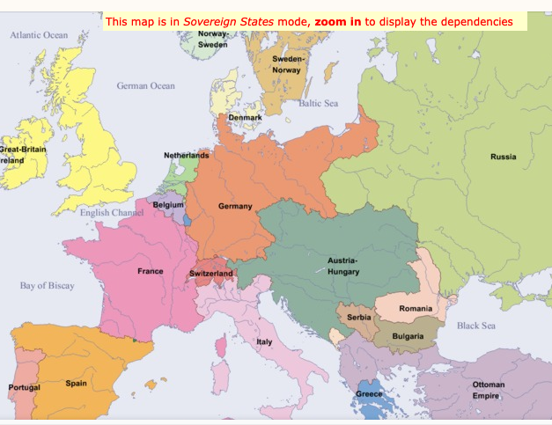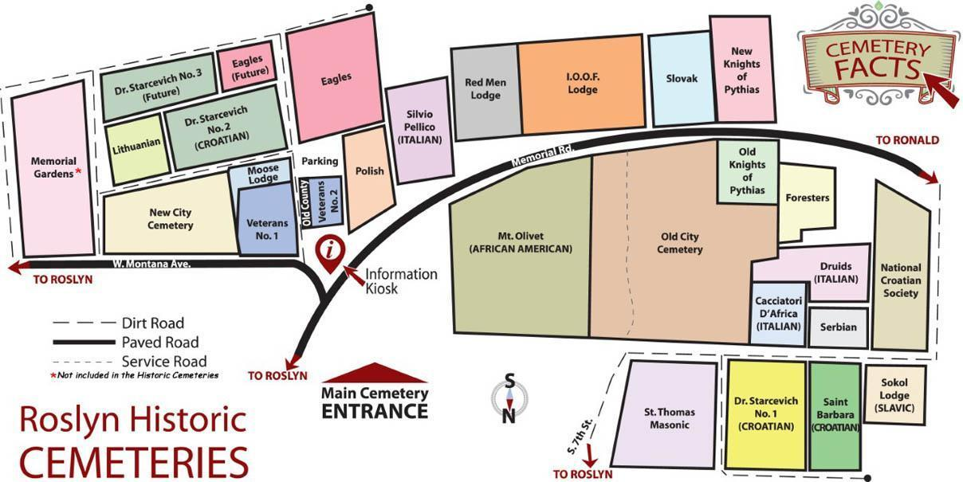

# **Immigration and Western Expansion, Fraternal Organizations & Lodges**

Roslyn’s cemetery was established the same year as the town, 1886. It is located on 12 acres full of hills and forest. It is in the southwest corner of the town and uses fences to mark boundaries of burial grounds. While the people of Roslyn were from various countries and cultures, living together and working together, they were not buried together.

Some of this separation came from **Fraternal organizations**. Fraternal organizations are like a social club, and many were established starting in the mid to late 1800s. Some fraternal organizations were established for people who wanted to get together to do kind things, to be **benevolent**. Others were created based on a shared religion, or a shared heritage. These organizations were an important part of Roslyn’s early days and helped the people to bond.

Fraternal organizations continued to grow, especially throughout the eighteenth and nineteenth centuries. Some examples of Fraternal organizations include a group for Croatians, called Sokol. Another example was for Italians, called Druids. Both of these groups formed in order to help the new immigrants settle into American life. There was also the Fraternal Order of Eagles and the Moose Lodge. These groups helped settlers that had already been living in the United States for a few generations. 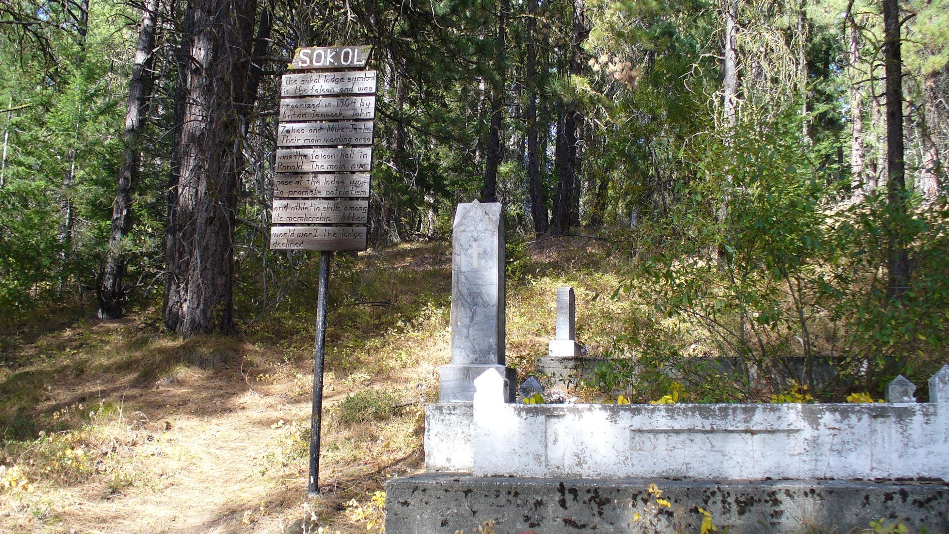

These groups and the bonds they formed can be seen in the cemetery. There are 27 individual cemeteries. Four of them are city cemeteries, also called **municipal** cemeteries. The other 23 are lodge cemeteries, or cemeteries for fraternal organizations; and includes the veterans cemetery. 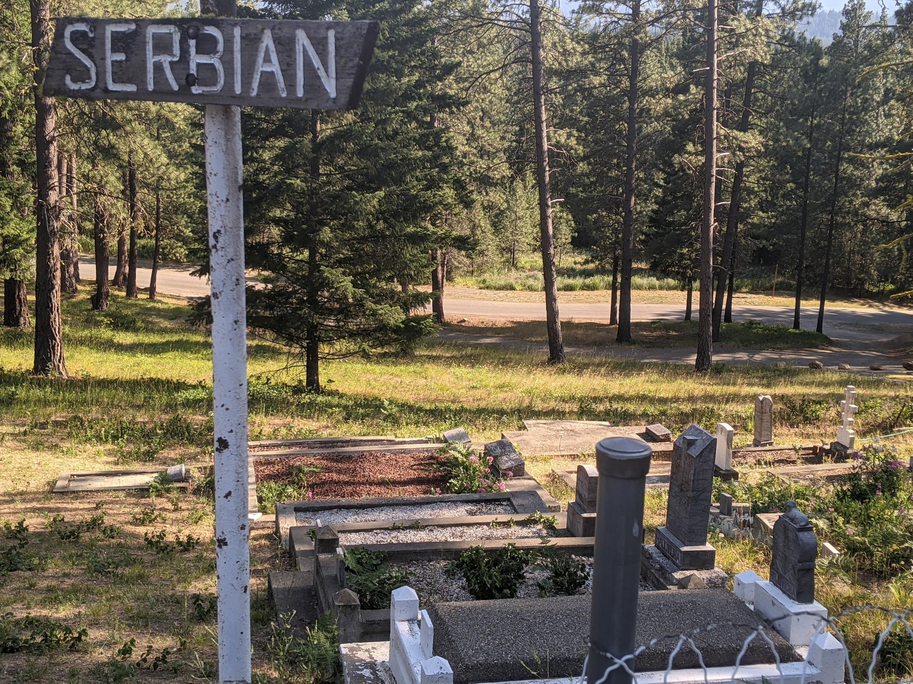

Fraternal organizations also helped provide support to families in everyday life, and in difficult situations. Fraternal organizations would host dances and picnics for members to attend. They would host fundraisers to help their community. Lodges, or fraternal organizations, would support their members culturally, socially, academically, and **civically** (their rights).

Fraternal organizations were also there to support during crisis. Mining was very dangerous work and accidents would often kill miners. This left their family with no help and no money. At the time, there were not as many government-provided safety nets, like **Social Security**, for families in such situations; instead, it was the lodges/fraternal organizations that would provide help and support to families in need. It is costly to pay for the remaining family after a death. It is also costly to pay for a funeral, casket, and burial needs. Fraternal organizations would help with all of this for its members. One way they did this was to buy sections of land near the main cemetery to bury their members. 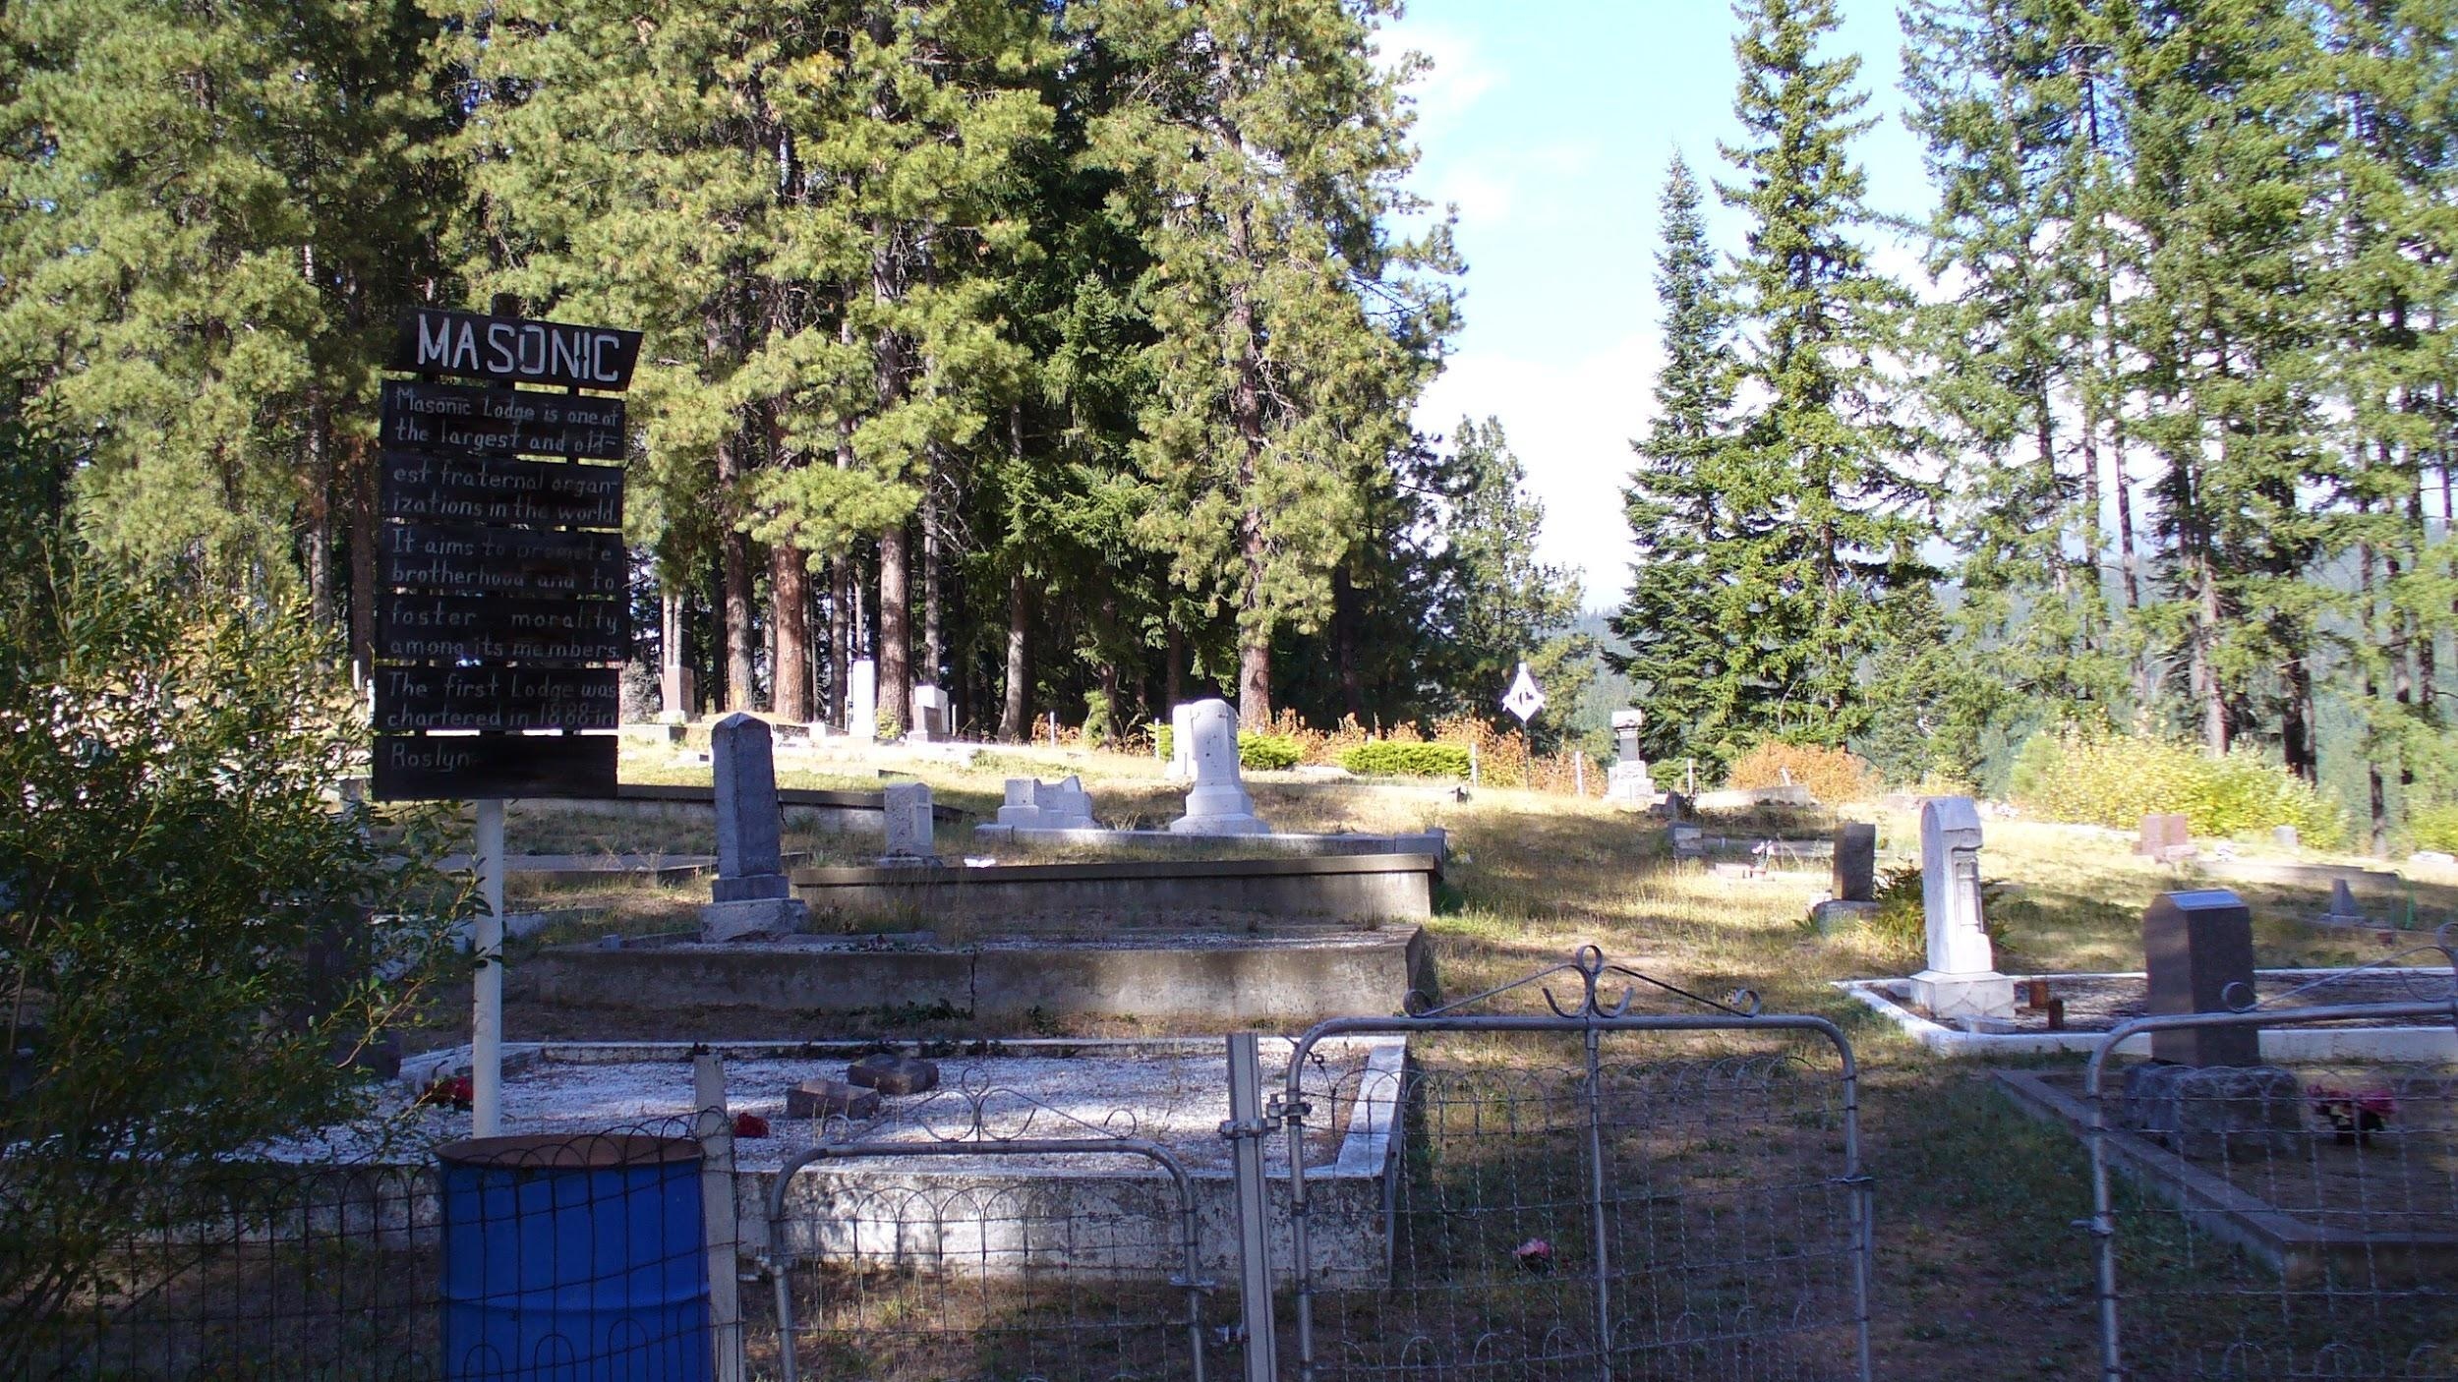

Burials continue at the Roslyn cemetery today. Walking through the cemetery shows Roslyn’s history. There are graves that are unmarked, instead circled by stones. Others have headstones with names and dates of those that have passed. The boundaries for Fraternal organizations are still clearly marked by fences. It has been estimated that the cemetery complex contains 5,000 graves.

|  |  |  |
| --- | --- | --- |
| **Word** | **Dictionary Definition** | **My Definition** |
| **Fraternal organizations** |  |  |
| **benevolent** |  |  |
| **municipal** |  |  |
| **Social Security** |  |  |
|  |  |  |
|  |  |  |

**Activity #1: Fraternal Organization Research**

Have students pick a Fraternal Organization to do more research about it. Students can use the following questions to get started. Then have them organize their findings into

* A 1 page informational overview
* Create a Google Slides presentation
* Use Canva (or something similar) to create an informational page
* Create a poster

Fraternal Organizations to Choose From

* Fraternal Order of Eagles
* Croatian Fraternal Union
* The Moose Lodge
* The Sokol
* Prince Hall Masonic Lodge
* Knights of Pythias
* Eastern Star
* Daughters of the Tabernacle

Research Questions

1. What is the name of the Fraternal Organization you are researching?
2. When was this organization founded or created?
3. Why was it created? (Religious, cultural connections?)
4. What kind of support did it provide?

**Activity #2: Language Research**

Independently, with partners, or in small groups, have students choose a language to research.

Language Options:

Italian

Polish

Croatian

Lithuanian

Serbian

Swedish

As a class brainstorm what words people would need to use on a daily basis, or trying to settle in a new town (I need work, how much does it cost?). You can also have students look up the words you would most often see on gravestones (Mother, Father, Son, etc)

Once you have your list of words, have students go online to translate the words into their chosen language.

Have students try to have a conversation with each other, but using the language they researched.

As a class, reflect on what it took for immigrants to be able to overcome language barriers and create a community.

**State Standards**

* H1.4.2 Examine how the following themes and developments help to define eras in Washington:
  + Immigration and settlement (1811-1889)
* H2.4.2 Analyze and explain how people from various cultural and ethnic groups have shaped Washington state history.

# **Essential Questions**

* Where does a community’s identity come from? How can individuals with so many different identities come together to form a community?
* What are important parts of community identity and how do they relate to each of us as individuals?

# **Essential Understandings**

* Identity is shaped by many complex social, political, historical, and cultural factors.
* The Roslyn Cemeteries reflect the area’s unique history of immigration
* The immigration patterns seen in the Roslyn Cemetery were similar to those throughout the western United States in the late 1800s and early 1900s

# **Teacher prep**

In preparation for this lesson read about:

The Roslyn Cemeteries

<https://www.nwpb.org/2018/05/25/in-roslyn-historic-cemeteries-connect-immigrant-past-to-present/>

Fraternal Orders

<https://www.encyclopedia.com/sports-and-everyday-life/social-organizations/private-organizations/fraternal-orders>