|  |  |
| --- | --- |
|  | **Roslyn Cemetery**  **Lesson One – Grade Four**  **Yakama Tribe Beginnings**  Roslyn is situated in the Cle Elum River Valley. This area was once a gathering ground for a group of the Yakama Nation. The Yakama tribe were a **semi-nomadic** group, meaning they moved from place to place, living on lands that went from Washington’s Cascade Mountains to the Columbia River. The Yakama tribe lived in the same way since **time immemorial**, meaning before people can remember or was even recorded.  Two Yakama Nation girls circa 1892-1899  For many centuries, food was easy to find along the Cle Elum River. The Yakama people hunted animals and gathered plants to eat. They fished the local areas and they traded with other tribes. To find the best food, they would travel to different places depending on the season.  In the winter they lived in villages southeast of Roslyn because it was warmer and had less snow. During summer and fall the Yakamas moved to camps along the Cle Elum River to hunt, fish, and to gather roots and berries. A white settler said this about the native Yakamas coming to the area: |
| *In those days, in the early fall, the Indians used to go up into the mountains, hunting and berry picking. I can remember the* ***caravans*** *of Indians sometimes a mile long; we would stand and watch, thinking the horses and gigs would never pass by.*  **--Robert Bell, Sr., Spawn of Coal Dust; A History of Roslyn,**  **1886-1955, Revised 2nd Edition, 1979, page 181** | |

In winter time the Yakama tribe lived in more **permanent** houses. They were called pit houses because they were built below the ground. They would use logs to make it sturdy and would use grasses and sod for insulation, to keep it warm.

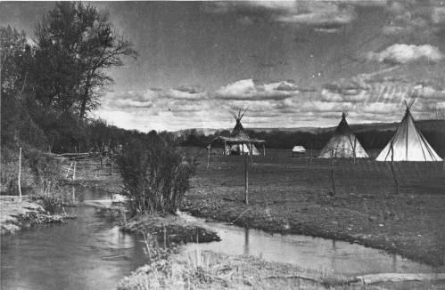

Indian camp in Kittitas County, Washington circa 1900 - 1919

In summer they lived in camps that were moveable. These structures were more like tepees, made of cattails, or **tules**, that were woven together and animal skins, like buffalo hides.

The Yakamas built canoes from hollowed-out logs of large trees. To make the canoes they would use fire to soften the wood, and then carve it into the right shape. These canoes were good for traveling on the rivers.

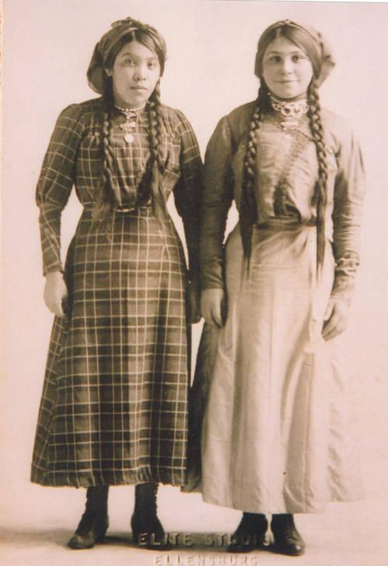

Lucie and Ida Joseph, sisters, Kittitas County, Washington, circa 1905

Lewis and Clark had an impact on the Yakama tribe. This began as early as 1805. The first white settlers began to arrive in the early 1860s. In May 1886 a team of **prospectors** from the Northern Pacific Railroad Company found coal.

More people moved to Roslyn to mine the coal. Many of these people were white, and caused the Native Americans to move. Moving away from this area meant that they no longer lived the way they used to. They would no longer have different homes for the different seasons.

Starting in the late 1800s the government began to create **Indian Reservations** across the United States. The Yakama people were moved onto the Yakama Indian Reservation.

|  |  |  |
| --- | --- | --- |
| **Vocabulary Word** | **Dictionary Definition** | **My Definition** |
| Semi-nomadic | People who have a base camp but also have moveable housing |  |
| Time immemorial | A time before people can remember; from the very beginning |  |
| Caravan | A group of people traveling together across a great distance |  |
| Permanent | To last forever; to not change |  |
| Tules | A large bush, much like cattails |  |
| Prospector | a person who searches for mineral deposits |  |
| Indian Reservation | A federal Indian reservation is **an area of land reserved for a tribe or tribes under treaty or other agreement** with the United States |  |

|  |  |
| --- | --- |
| **Before You Read: All About You** | **After You Read: All about Yakama Natives** |
| Do you know when your family first moved here? If so, when? | When did the Yakama Natives first move here? |
| Where do you get your food from? | Where did the Yakama Natives get their food from? |
| Describe where you live, your house or your room | Describe the houses and structures that Yakama natives lived in |
| What activities do you like to do locally? | What activities did the Yakama Natives participate in locally? |
| What kind of transportation do you use? How do you get from place to place? | What kind of transportation did the Yakama Natives use? How did they get from place to place? |
|  |  |

**Activity #1: Write a Detailed Description of One of the Photographs**

Choose one of the photographs from the above reading, and write and describe everything you can about it. What do you notice? What do you see?

**Activity #2: Choose One of the Photographs and Write a Creative Story Or A Poem Based On It**

**State Standards**

C3.4.1 Recognize that tribes have lived in North America since time immemorial.

H3.4.3 Explain how the events of Washington state history contributed to the different perspectives between native and non-native people.

G1.4.1 Construct and use maps to explain the movement of peoples.

**Essential Questions:**

* Who were the indigenous people of Roslyn/Kittitas County?
* How did the indigenous people live around Roslyn before the white settlers came?
* What happened to the Yakamas who lived around Roslyn?
* How do you think the Yakamas felt about being forced out of their summer camping spots? Do you think their feelings about white settlers were positive?

**Essential Understandings:**

* Students will understand how U.S. expansion of territory and transportation impacted the indigenous people who first lived in Eastern Washington.

**Sources**

Yakama Tribe

[**https://www.warpaths2peacepipes.com/indian-tribes/yakama-tribe.htm**](https://www.warpaths2peacepipes.com/indian-tribes/yakama-tribe.htm)

Oliver, N. & Camuso, C. (2017). Cultural Resources Evaluations <https://cityofcleelum.com/wp-content/uploads/2018/09/Howard-Carlin-Project-Report-5.26.17.pdf>

**Teacher prep**

In preparation for this lesson read the full Thumbnail History of Roslyn text at <https://www.historylink.org/File/9239>

And pages 3-13 of the Cultural Resources Evaluations <https://cityofcleelum.com/wp-content/uploads/2018/09/Howard-Carlin-Project-Report-5.26.17.pdf>

**Discovery of Coal in Roslyn**

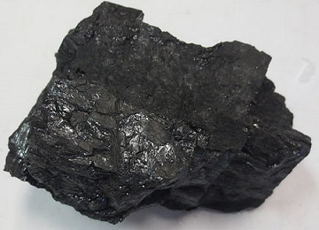

Lump of coal, an energy rich fossil fuel that has been used to fuel steam locomotives, to heat homes, and to fuel electric power plants around the world

The discovery of **coal** forever changed the lives of the Yakama people around Roslyn because it brought in white **settlers**. But what is coal? Coal is a rock that burns. Coal is mostly made from the chemical carbon. Coal started out as plants that over time were compacted, or squished. Over time this compacting caused it to harden. Due to this pressure and the addition of heat, the carbon would chemically change into coal.

Coal takes a long time to form. It is found where forests and swamps existed millions of years ago, called **prehistoric** forests and swamps. These forests and swamps were covered up by other land formations, which caused the pressure and heat needed to create coal.

Once it has fully formed coal is black or brownish-black. Because it burns it has been used as fuel for centuries. Coal is considered a **natural resource**, meaning it was created naturally and can be useful to humans. Because it formed underground, coal must be mined.

In Roslyn’s coalfields mines tunneled deep underground. Miners looked for **seams of coal**, or the layer of coal between other layers of rock. Once they found the seam of coal, they would dig it out. Then they used mules or electric powered carts to haul the coal to the surface.

Much of Roslyn’s coal was used to fuel the steam **locomotives** that pulled trains over the Cascade Mountains. Roslyn was a major coal producer until the 1930s. In the 1930s coal was used less as a fuel because people started using diesel fuel instead. The last Roslyn mine closed in December 1963.

**Arrival of the Railroad**

Railroads and trains were an important way to travel, and in 1864 the U.S. Congress was helping to expand trains further and further. They were trying to establish a train that would go from the Great Lakes, near Michigan and Wisconsin, to Puget Sound, in Western Washington. This trip would take many months in horse drawn wagons; but, in a train was only a 5- to 6-day trip.

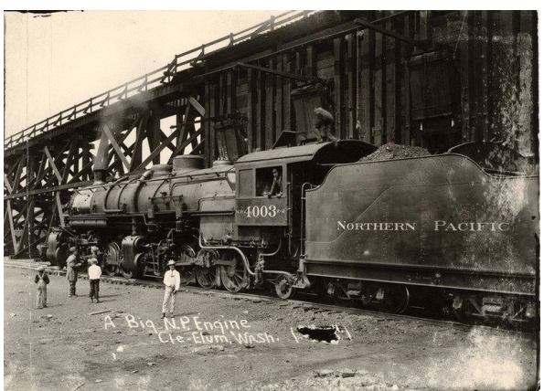

Northern Pacific locomotive loading coal in Cle Elum, 1910. (Photo courtesy of Dr. James E. Brooks Library, Archives and Special Collections, Frederick Krueger Collection, Central Washington University, Ellensburg, WA)

Coal and railroads in Roslyn are connected. The Northern Pacific Railroad Company specifically sent out prospectors to find coal to fuel their steam locomotives, or trains. In 1886 their prospectors found coal in Roslyn.

Roslyn’s **geology** and **geography** created coal fields. Once that coal was found by the railroad, it was mined and used to fuel locomotives. The Northern Pacific Railroad and its coal mines built the community of Roslyn. The work in coal brought in workers from around the U.S. and from Europe. A direct link connects the discovery of Roslyn’s coal to the building and development of Roslyn.

|  |  |  |
| --- | --- | --- |
| **Vocabulary Word** | **Dictionary Definition** | **My Definition** |
| Coal | a hard, black substance that is dug from the earth in pieces, and can be burned to produce heat or power |  |
| Settlers | a person who moves with a group of others to live in a new country or area |  |
| Prehistoric | period before written records |  |
| Natural Resource | materials or substances such as minerals, forests, water, and [fertile](https://www.google.com/search?safe=active&sca_esv=577922779&rlz=1C1GCEA_enUS1002US1002&q=fertile&si=ALGXSla6aFUzqw8hZDovT8H5OBVE02NLUkD47_i0j8Uf3DEKEN-llvthB5vTa5xMbui-M2aVUUHhAOo10Ia55pbVbmMnfAg7ezLvnaAgw7MGBFWbbHQ4J_c%3D&expnd=1) land that occur in nature and can be used for gain |  |
| Locomotive | a powered rail vehicle used for pulling train |  |
| Seam of coal | A visible layer of dark coal between other layers of rock |  |
| Geology | the science that deals with the earth's physical structure and substance, its history, and the processes that act on it. |  |
| Geography | the study of the physical features of the earth and its atmosphere |  |

**Activity #3: Fossil Fuel Research**

In pairs, students research coal as a fossil fuel. Have students make a T Chart for the pros and cons of using coal as fuel.

**Activity #4:**

Show students video, How steam locomotives work at: <https://www.youtube.com/watch?v=nd2Ii4OGQ4k>

Direct students to draw a steam locomotive with a tender carrying coal. Encourage students to label the parts of their train.

Also encourage students to be creative and come up with a logo for the train, maybe one that would represent Roslyn and its history of coal.

**State Standards**

E4.4.1 Explain how geography, natural resources, climate, and available labor contributed to the exploitation of resources in the Pacific Northwest. [Note: Labor is addressed in Units 2-5].

**Essential Questions:**

* How was coal formed?
* How was coal removed from underground coal fields?
* What purpose did coal serve (e.g., power for steam locomotives, heat for homes)?
* Why was coal used to power RR locomotives in the 1880's? (e.g., coal was easily available & combustible, gasoline combustion engine not invented)

**Essential Understandings:**

* Students will understand how a natural resource source builds a town
* Students will understand what coal is, how it was discovered and why the discovery was critical to the railroad and the community
* Students will understand the adverse environmental impacts of burning coal

**Videos**

What do steam engine trains look like, sound like?

<https://www.youtube.com/watch?v=C6U8fF5TrfA>

How do steam locomotives work?

<https://www.youtube.com/watch?v=nd2Ii4OGQ4k>

**Additional Source on Railroads**

[**https://www.legendsofamerica.com/northern-pacific-railroad/**](https://www.legendsofamerica.com/northern-pacific-railroad/)

[**https://www.discovercleelum.com/history/cle-elum-firsts-washington-state-history/first-train-in-cle-elum/**](https://www.discovercleelum.com/history/cle-elum-firsts-washington-state-history/first-train-in-cle-elum/)

**Additional Reading**

Franklin, Kristine L. Grape Thief. Candlewick Press, Cambridge, MA, 2003.